**Task 1 - Tabs**

**Description**

* Implement a function that accepts a **CSS selector** and an array of **tabs** as parameters and builds a tabs view with DOM structure and behaviour as described below.
  + The **CSS selector** will be a string.
  + Each **tab** has properties **title** and **content**. Both are strings.

**DOM Structure**

* Inside the selected element, you need to build the following elements:
  + A ul with class .tabs-nav for the tabs navigation.
    - For each **tab**, build a li that contains an anchor element with class .tab-link and content - the **title of the tab**.
  + A ul with class .tabs-content for displaying the content of the tabs.
    - For each **tab**, biuld a li that has class .tab-content and contains two elements:
      * a p element whose content is the **content** of the tab.
      * a button element with class .btn-edit and text **Edit**.
    - The first li **should** have class .visible.

**Behaviour**

* When a .tab-link item is clicked, the **content of the respective tab should be displayed**. Use the .visible class on li.tab-content to display contents.
* When a .btn-edit with text **Edit** is clicked, the following two things should happen:
  + The text of the clicked .btn-edit should be changed to **Save**.
  + A textarea element with class .edit-content should be added to the li.tab-content, which is the clicked button's parent.
    - The textarea should have the same content as the content of the **tab**.
* When a .btn-edit with text **Save** is clicked, the following three things should happen:
  + The content of the displayed **tab** should be set to the value of the textarea.
  + The textarea should be **removed from the DOM**.
  + The text of the .btn-edit should be set back to **Edit**.

**Pictures**

* Assume you are given the following tabs as input parameter:

[

{ title: 'Gosho', content: 'Superhero from Kazichene' },

{ title: 'Ivan', content: 'Criminal from Goren Okol' },

{ title: 'Stamat', content: 'Crime lord from Burgas' },

{ title: 'Stanislav', content: 'Travelling salesman from Busmantsi' }

]

* After building the DOM structure

[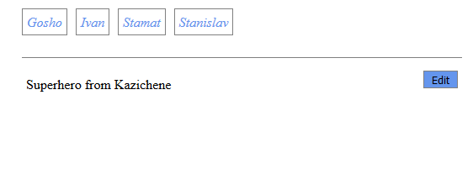](https://github.com/TelerikAcademy/JavaScript-UI-and-DOM/blob/master/Practical%20Exams/22-August-2016/task-1/imgs/built-initial.png)

* After clicking on *Ivan* .tab-link

[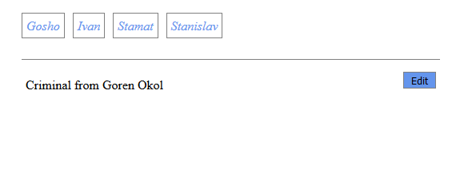](https://github.com/TelerikAcademy/JavaScript-UI-and-DOM/blob/master/Practical%20Exams/22-August-2016/task-1/imgs/ivan-clicked.png)

* After clicking the **Edit** button

[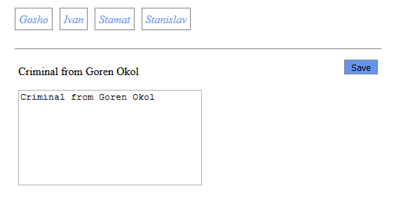](https://github.com/TelerikAcademy/JavaScript-UI-and-DOM/blob/master/Practical%20Exams/22-August-2016/task-1/imgs/edit-click.png)

* Editing the content

[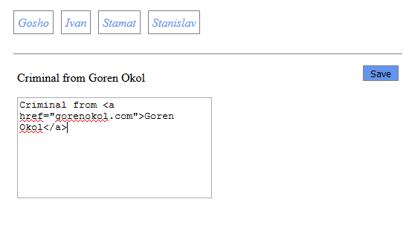](https://github.com/TelerikAcademy/JavaScript-UI-and-DOM/blob/master/Practical%20Exams/22-August-2016/task-1/imgs/editing-content.png)

* After clicking the **Save** button

[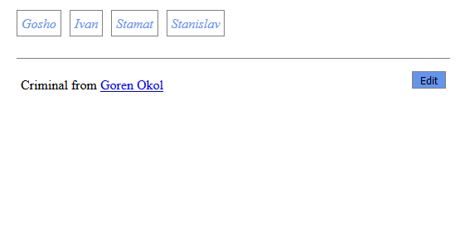](https://github.com/TelerikAcademy/JavaScript-UI-and-DOM/blob/master/Practical%20Exams/22-August-2016/task-1/imgs/save-click.png)

**Constraints**

* **DO NOT** use inline styles. You only need the classes from main.css.
* **DO NOT** use innerText.

**Running the unit tests locally**

* Open the command prompt/terminal in this directory.
* Execute the command npm install.
* Execute the command npm test.

**Submission**

* Your submission should be in the following format:

function solve() {

return function (selector, tabs) {

// your solution here

}

}